Jack Johnson

August 12, 2021

Section Project: Cart Management

Link to my GitHub repository: <https://github.com/jjohn98/2058519_Jack_Johnson_Mean_Stack>

This project is located in ~/Phase2/Cart Management.

In this project, I created 3 files, and then when converting the Typescript file to a JavaScript file a 4th file was created. ShoppingHome.html contains the home page with the products which can be added to the cart. ShoppingCart.html contains the table which populates with the items the user has placed in the cart, and also shows the total price of all the items in the cart.

CartManagement.ts contains all of the typescript code required to run the home and cart pages. The addToCart() function takes a product object and places it into the JSON array which is then stringified and placed into local storage. getData() takes the data out of local storage and then populates the table on the cart page with the items from the cart. The total is stored when items are added to the cart and displayed at the bottom of the cart page after getting pulled from local storage.

I do get a weird error, but everything works so I chose to ignore it just to save time turning in this project.

Screenshot of Web pages created:

**ShoppingHome.html:**

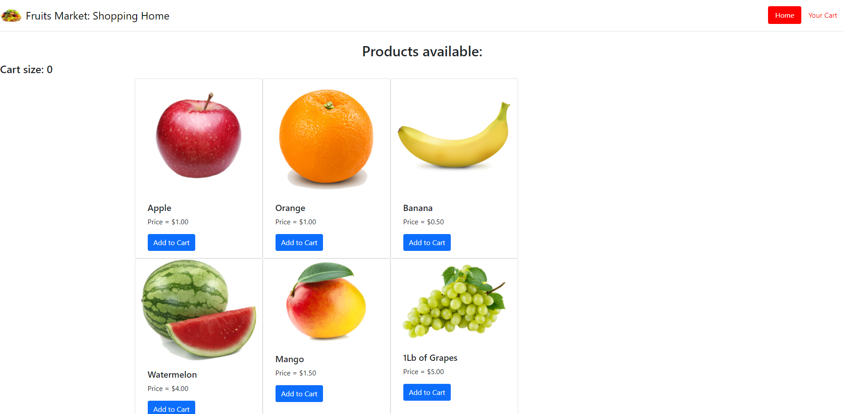

**ShoppingCart.html:**

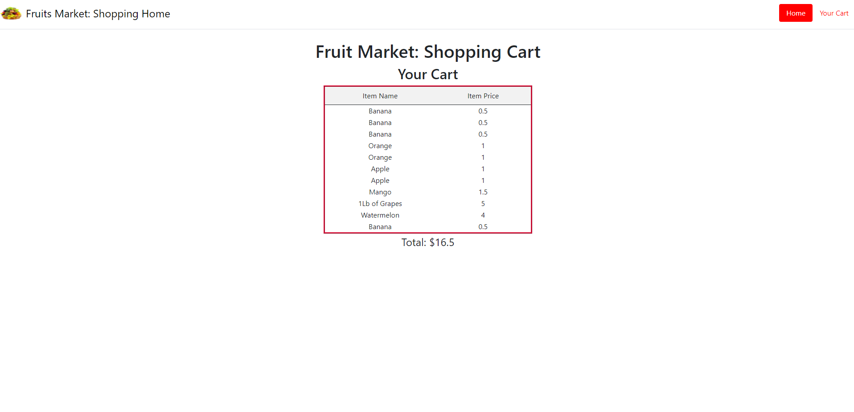

The files for this project will be in the GitHub repository, as well as the source code section of the submission on Simplilearn.